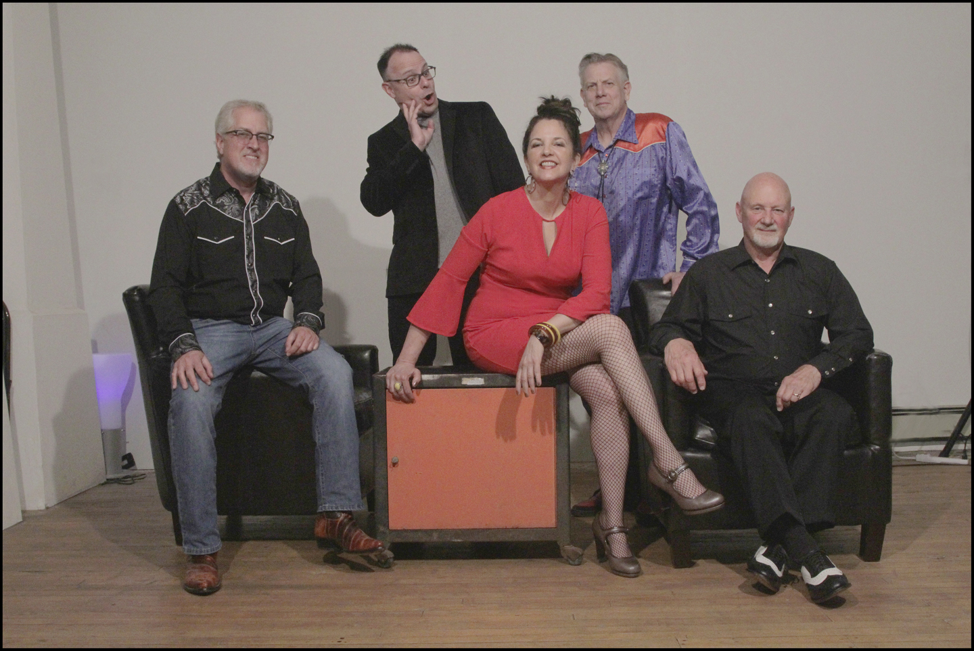

THE COW PONIES is an alt country/old country/cowpunk band from Milwaukee, Wisconsin.
After guitarist/singer-songwriter John Graham of the popular Eighties rockabilly band The Rock-A-Dials founded The Cow Ponies in early 2015, we played our first show that December at Circle A in Riverwest. John and Tom T, bass player from another renowned Eighties band, Those XCleavers, write all of our original music; we also put our own spin on old country, Western, and honky-tonk classics. Robin Graham, lead vocals, Andy Stilin, drums, and Keith Bolog on steel guitar round out our sound. In 2018 we were nominated for a WAMI Award for “Best Country Artist.”
To date, we are honored to have played in such fine venues as WMSE-Local Live, Linneman’s, Kochanski’s, Club Girabaldi, Chill on the Hill, and Summerfest. We released our first CD, “Easy to Fall,” December 2017. Our second CD, produced by Mike Hoffman of Semi-Twang and The Delta Routine, is due out late 2019.
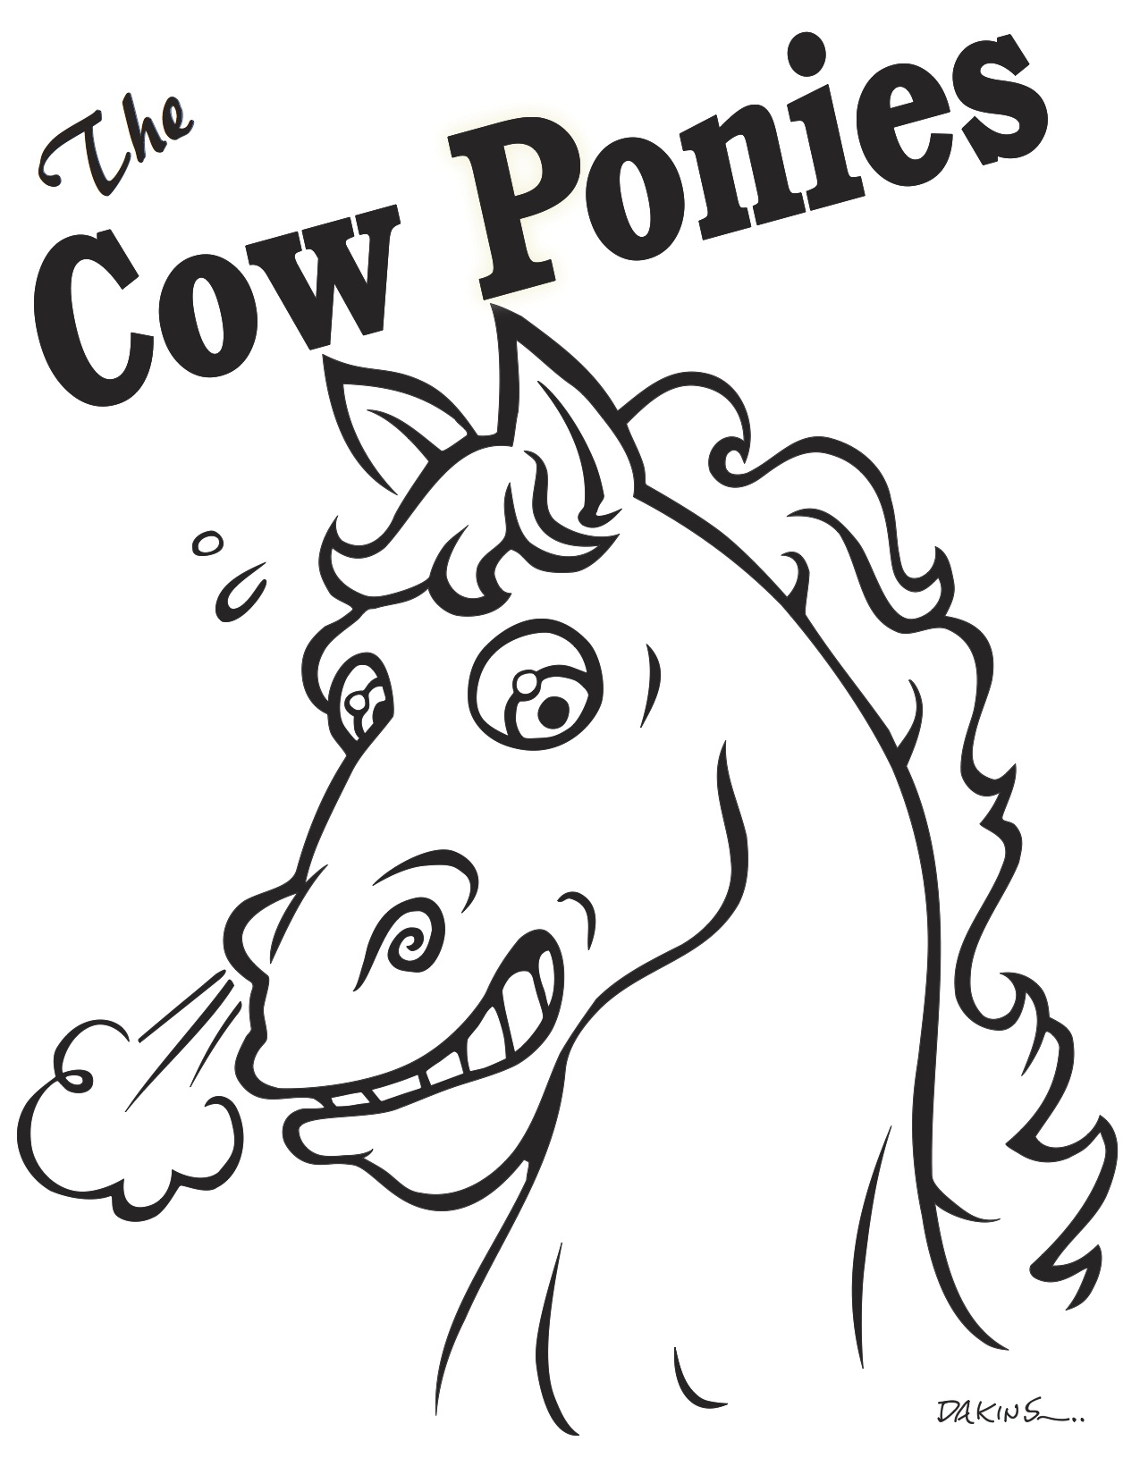
Email: info@thecowponies.com
Web: thecowponies.com
Facebook: facebook.com/thecowponies/
Twitter + Instagram: @thecowponies
CD Baby: store.cdbaby.com/cd/thecowponies
ReverbNation: reverbnation.com/thecowponies
Bandcamp: thecowponies.bandcamp.com/releases
SoundCloud: soundcloud.com/the-cow-ponies

